Analysis and visualization
2026-05-10
This is an R Markdown document for easy access to and recreation of the figures for the manuscript “Measuring the health benefits, costs, and cost-effectiveness of antimicrobial-resistant gonorrhea surveillance in the United States”, currently in revision at Lancet Public Health Americas.
#calibration and main text
load("figure data/sweepdata.RData")
load("figure data/parcaldata.RData")
load("figure data/calnoresist.RData")
load("figure data/mainresults.RData")
#supplement data
load("figure data/drugXresults.RData")
load("figure data/gispswitchdata.RData")
load("figure data/adherencesymptomaticresults.RData")
load("figure data/adherenceasymptomaticresults.RData")
load("figure data/dstdata.RData")
load("figure data/comboandmixedtesting.RData")
load("figure data/fitnessCostData.RData")

Figure 1
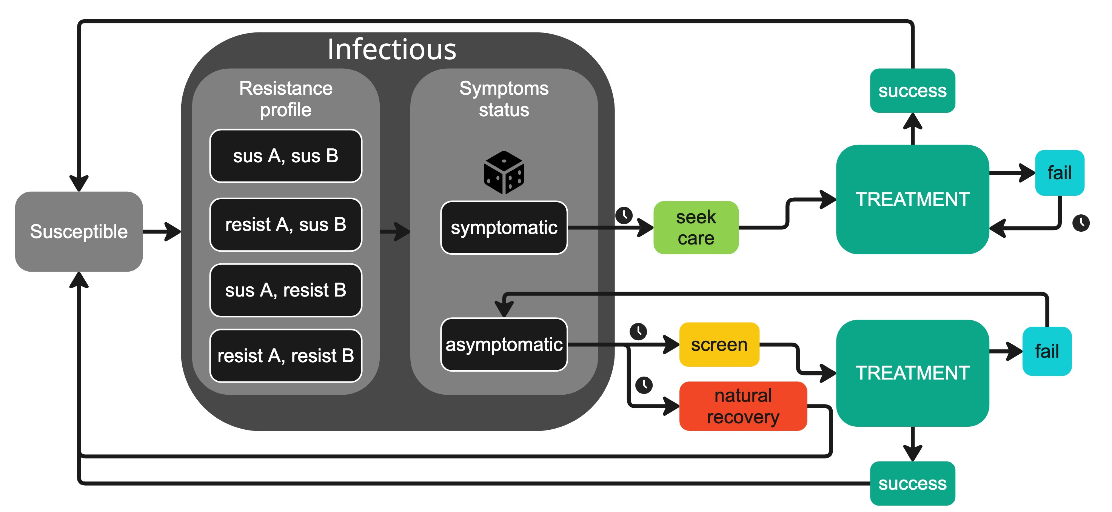
Figure 1.
Figure 1. Diagram of the major processes of the model, showing the generic treatment pathway. “sus A” and “sus B” represent susceptibility to drug A and drug B, respectively, and “resist A” and “resist B” represent resistance to drug A and drug B, respectively. Dice icon indicates a pseudo-random event, whose probability is controlled by a parameter. The clock icon indicates that time elapses before the next event occurs; arrows without clock icons indicate that the next event takes place immediately (except for treatment success, which has a delay of 3 days on average).

Calibration

Figure 2
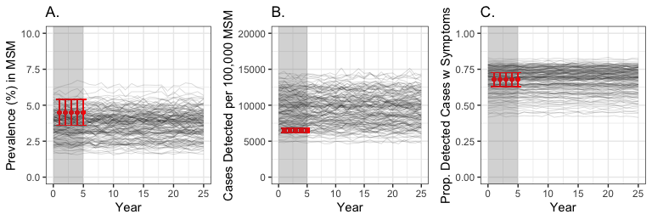
Figure 2. Comparing calibration targets (shown in red) with simulated trajectories without AMR for 25 years. A) prevalence of infection. B) gonorrhea cases detected per 100,000. C) proportion of detected cases that present with symptoms. Darkness of the black lines relates to how frequently that trajectory was resampled, according to its likelihood when compared to the calibration target. Red dots indicate the observed value, and the red error bars indicate the confidence interval (see text for data sources). The grey region represents the calibration period.

Figure 3
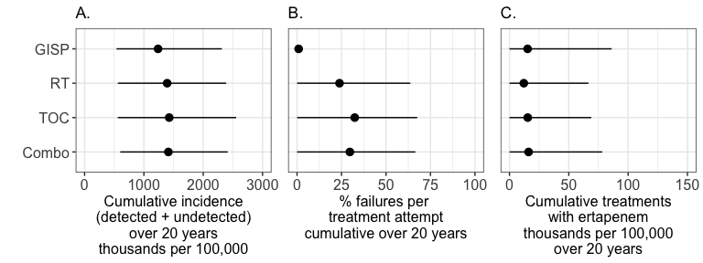
Figure 3. Cumulative outcomes for the four mitigation strategies, beginning at the end of the calibration period and continuing to the end of each simulation. Dot indicates the mean model prediction; line corresponds to the 95% uncertainty interval (i.e., extending from the 2.5% quantile to the 97.5% quantile). A) total infection incidence, including both detected and undetected infections. B) percentage of treatment attempts that resulted in treatment failure for drugs A, B, and X. C) count of treatments with ertapenem

Figure 4
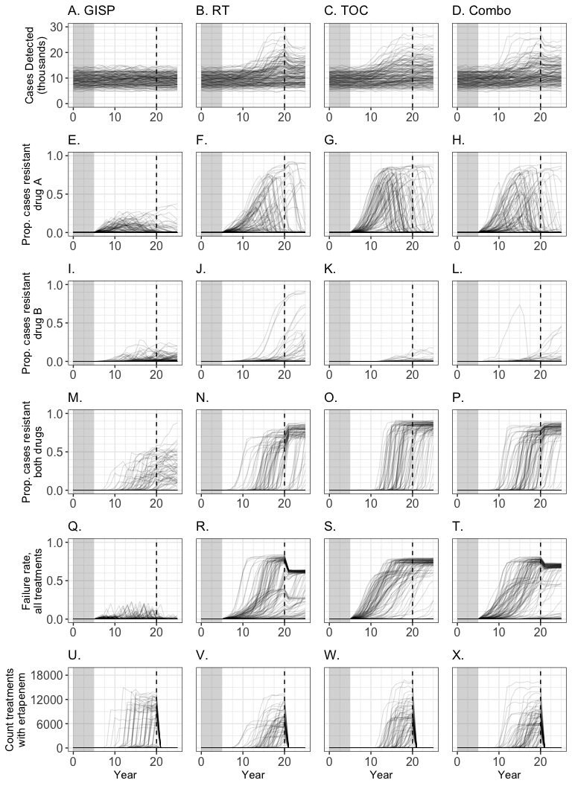
Figure 4. Trends over time in cases detected (first row), prevalence of AMR strains (rows 2-4), treatment failure rate (row 5), and usage of ertapenem, the last-line treatment (row 6) across four strategies. GISP: the surveillance strategy; RT: randomized treatment strategy; TOC: test-of-cure strategy; Combo: combination of RT and TOC. The gray box indicates the calibration period, during which all strategies performed identically. The dashed vertical line indicates when drug X became available in the simulation. Darkness of trajectory lines relates to their likelihood weights (see S1.3).

Figure 5
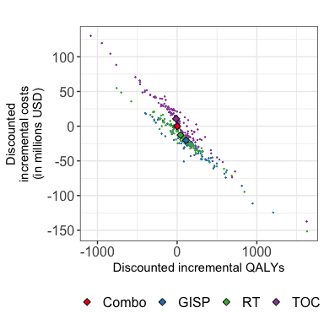
Figure 5. Cost-effectiveness analysis of GISP and three counterfactual strategies. Combination of TOC and RT (Combo) is used as the reference strategy, located at (0,0). Small dots are values from individual trajectories, diamonds are means of each counterfactual (mean was weighted by how frequently that trajectory had been resampled during calibration.)

Table 1 Mean Cumulative Results
Table 1. Mean cumulative results (uncertainty intervals) of four measures of gonorrhea burden: gonorrhea incidence, antimicrobial-resistant (AMR) gonorrhea incidence, treatment failure rate, and total count of treatments with ertapenem
 | GISP | Randomized Treatment (RT) | Test of Cure (TOC) | Combo
Incidence Mean | 1238506.97 | 1392132.52 | 1426754.52 | 1412679.02
Incidence Quantiles | 538727.4, 2314388.05 | 560649.6, 2387418.3 | 559395.45, 2555639.4 | 600729.05, 2414348.85
resistance Mean | 105564.05 | 530854.22 | 631123.19 | 575309.59
Resistance Quantiles | 211.5, 450040.25 | 243.95, 1720638.85 | 342.85, 1916133.35 | 294.1, 1785877.85
Failure Mean | 0.91 | 23.87 | 32.42 | 29.7
Failure Quantiles | 0.02, 3.25 | 0.03, 63.66 | 0.02, 67.56 | 0.03, 66.48
Ertapenem Mean | 15271.68 | 12089.02 | 15378.66 | 16102.78
Ertapenem Quantiles | 0, 86134.3 | 0, 66564.9 | 0, 68972.95 | 0, 78265.05
Cumulative results of gonorrhea burden under GISP and three counterfactual strategies, beginning at the end of the calibration period (year 5). Presented are the means of 143 unique trajectories; in parentheses are the 95% uncertainty intervals, derived from the 2.5% and 97.5% quantiles of the simulated data. Cumulative incidence of gonorrhea includes both detected and undetected infections. Cumulative incidence of antimicrobial-resistant (AMR) gonorrhea includes both detected and undetected infections of all resistant strains, combined. Treatment failure rate is calculated as the number of treatment failures divided by the number of all treatment attempts. *GISP: Gonococcal Isolate Surveillance Project, where treatments were removed from use when GISP surveillance data indicated AMR resistance of 5% or greater. †RT: Randomized Treatment, where treatment was selected randomly from available drugs. ‡TOC: Test-of-Cure, where some cases received confirmatory diagnostic testing after treatment attempts. §Combo: Combination, where cases were randomly assigned to RT or TOC

Data for main text
ceadf <- cea_real_unweighted_noDST(dfreal25, dfGISP25, dfrandom25, dfTOC25)
sum(ceadf$GISPcumulativeCosts < ceadf$RCcumulativeCosts & ceadf$GISPcumulativeCosts < ceadf$TOCcumulativeCosts & ceadf$GISPcumulativeCosts < ceadf$RandomcumulativeCosts)
## [1] 74
sum(ceadf$GISPcumulativeCosts < ceadf$RCcumulativeCosts & ceadf$GISPcumulativeCosts < ceadf$TOCcumulativeCosts & ceadf$GISPcumulativeCosts < ceadf$RandomcumulativeCosts) / 143
## [1] 0.5174825
sum(ceadf$GISPcumulativeQALYs < ceadf$RCcumulativeQALYs & ceadf$GISPcumulativeQALYs < ceadf$TOCcumulativeQALYs & ceadf$GISPcumulativeQALYs < ceadf$RandomcumulativeQALYs)
## [1] 67
sum(ceadf$GISPcumulativeQALYs < ceadf$RCcumulativeQALYs & ceadf$GISPcumulativeQALYs < ceadf$TOCcumulativeQALYs & ceadf$GISPcumulativeQALYs < ceadf$RandomcumulativeQALYs) / 143
## [1] 0.4685315
sum(ceadf$RandomcumulativeCosts < ceadf$RCcumulativeCosts & ceadf$RandomcumulativeCosts < ceadf$TOCcumulativeCosts & ceadf$RandomcumulativeCosts < ceadf$GISPcumulativeCosts)
## [1] 56
sum(ceadf$RandomcumulativeCosts < ceadf$RCcumulativeCosts & ceadf$RandomcumulativeCosts < ceadf$TOCcumulativeCosts & ceadf$RandomcumulativeCosts < ceadf$GISPcumulativeCosts) / 143
## [1] 0.3916084
sum(ceadf$RandomcumulativeQALYs < ceadf$RCcumulativeQALYs & ceadf$RandomcumulativeQALYs < ceadf$TOCcumulativeQALYs & ceadf$RandomcumulativeQALYs < ceadf$GISPcumulativeQALYs)
## [1] 22
sum(ceadf$RandomcumulativeQALYs < ceadf$RCcumulativeQALYs & ceadf$RandomcumulativeQALYs < ceadf$TOCcumulativeQALYs & ceadf$RandomcumulativeQALYs < ceadf$GISPcumulativeQALYs) / 143
## [1] 0.1538462
sum(ceadf$TOCcumulativeCosts < ceadf$RCcumulativeCosts & ceadf$TOCcumulativeCosts < ceadf$RandomcumulativeCosts & ceadf$TOCcumulativeCosts < ceadf$GISPcumulativeCosts)
## [1] 5
sum(ceadf$TOCcumulativeCosts < ceadf$RCcumulativeCosts & ceadf$TOCcumulativeCosts < ceadf$RandomcumulativeCosts &
ceadf$TOCcumulativeCosts < ceadf$GISPcumulativeCosts) / 143
## [1] 0.03496503
sum(ceadf$TOCcumulativeQALYs < ceadf$RCcumulativeQALYs & ceadf$TOCcumulativeQALYs < ceadf$RandomcumulativeQALYs &
ceadf$TOCcumulativeQALYs < ceadf$GISPcumulativeQALYs)
## [1] 34
sum(ceadf$TOCcumulativeQALYs < ceadf$RCcumulativeQALYs & ceadf$TOCcumulativeQALYs < ceadf$RandomcumulativeQALYs & ceadf$TOCcumulativeQALYs < ceadf$GISPcumulativeQALYs) / 143
## [1] 0.2377622
sum(ceadf$RCcumulativeCosts < ceadf$RandomcumulativeCosts & ceadf$RCcumulativeCosts < ceadf$TOCcumulativeCosts & ceadf$RCcumulativeCosts < ceadf$GISPcumulativeCosts)
## [1] 8
sum(ceadf$RCcumulativeCosts < ceadf$RandomcumulativeCosts & ceadf$RCcumulativeCosts < ceadf$TOCcumulativeCosts & ceadf$RCcumulativeCosts < ceadf$GISPcumulativeCosts) / 143
## [1] 0.05594406
sum(ceadf$RCcumulativeQALYs < ceadf$RandomcumulativeQALYs & ceadf$RCcumulativeQALYs < ceadf$TOCcumulativeQALYs & ceadf$RCcumulativeQALYs < ceadf$GISPcumulativeQALYs)
## [1] 20
sum(ceadf$RCcumulativeQALYs < ceadf$RandomcumulativeQALYs & ceadf$RCcumulativeQALYs < ceadf$TOCcumulativeQALYs & ceadf$RCcumulativeQALYs < ceadf$GISPcumulativeQALYs) / 143
## [1] 0.1398601

Table 2 CEA results table
Table 2. Cost-effectiveness results: Cost, number of quality-adjusted life years (QALYs), and incremental cost-effectiveness ratios for four strategies.
 | GISP | Randomized Treatment (RT) | Test of Cure (TOC) | Combo
Cost Mean | 43.2 | 50.93 | 74.4 | 63.68
Cost Quantiles | 24.19, 72.04 | 24.89, 98.01 | 30.46, 154.6 | 29.04, 131.29
QALY Mean | 399.99 | 470.32 | 525.9 | 512.97
QALY Quantiles | 180.15, 822.45 | 170, 1080.46 | 175.72, 1277.04 | 169.61, 1192.44
The strategies are listed in increasing order of cost. Costs and QALYs were cumulative from year 5 to year 25 in the model, with 3% discounting year-over-year. Presented are the means of 143 unique trajectories; in parentheses are the 95% uncertainty intervals, derived from the 2.5% and 97.5% quantiles of the simulated data. Costs are in 2022 United States dollars (USD). *GISP: Gonococcal Isolate Surveillance Project, where treatments were removed from use based on surveillance †RT: Randomized Treatment, where treatment was selected randomly from available drugs ‡Combo: Combination, where cases were randomly assigned to RT or TOC §TOC: Test-of-Cure, where some cases received confirmatory diagnostic testing after treatment attempts ¶QALYs: Quality-Adjusted Life-Years. These values represent decrements in QALYs that resulted from gonorrhea. #ICER: incremental cost-effectiveness ratio

Supplements

Supplement 1 Model Description

Figure S1, model diagram for GISP and RT
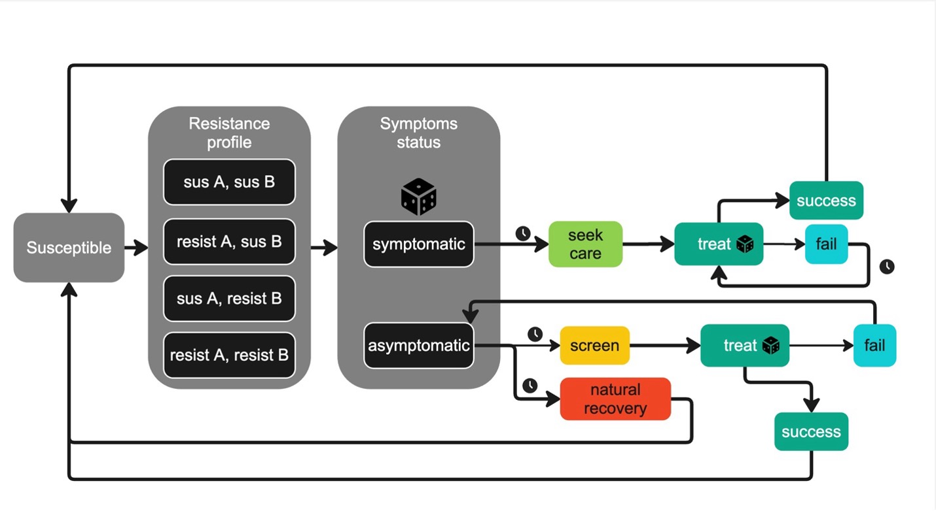
Figure S1.

Figure S2, Model diagram for TOC
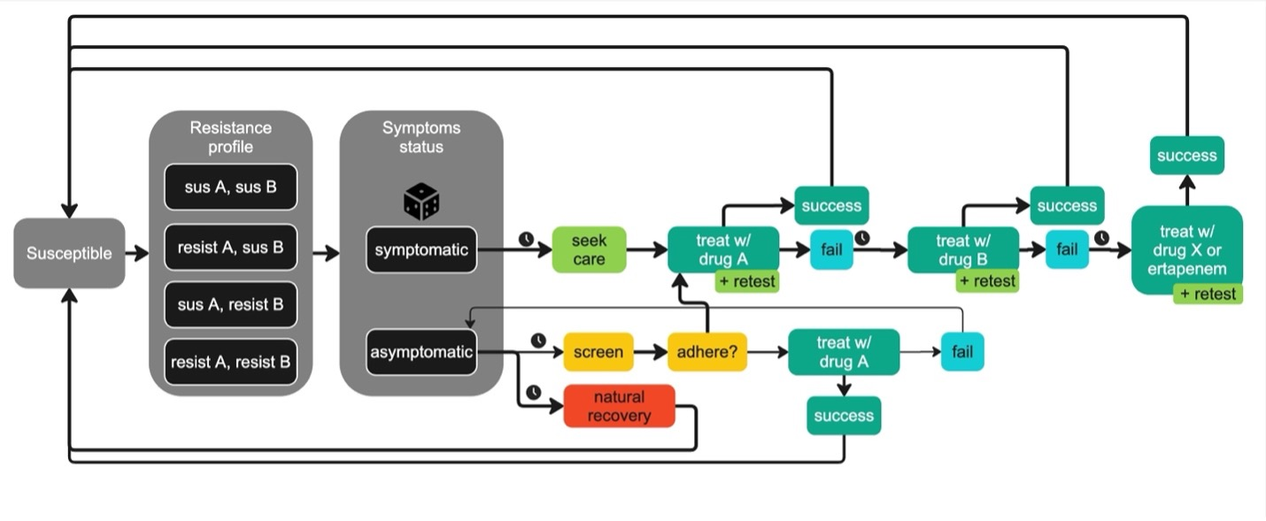
Figure S2.

Figure S3, Posterior parameter estimates
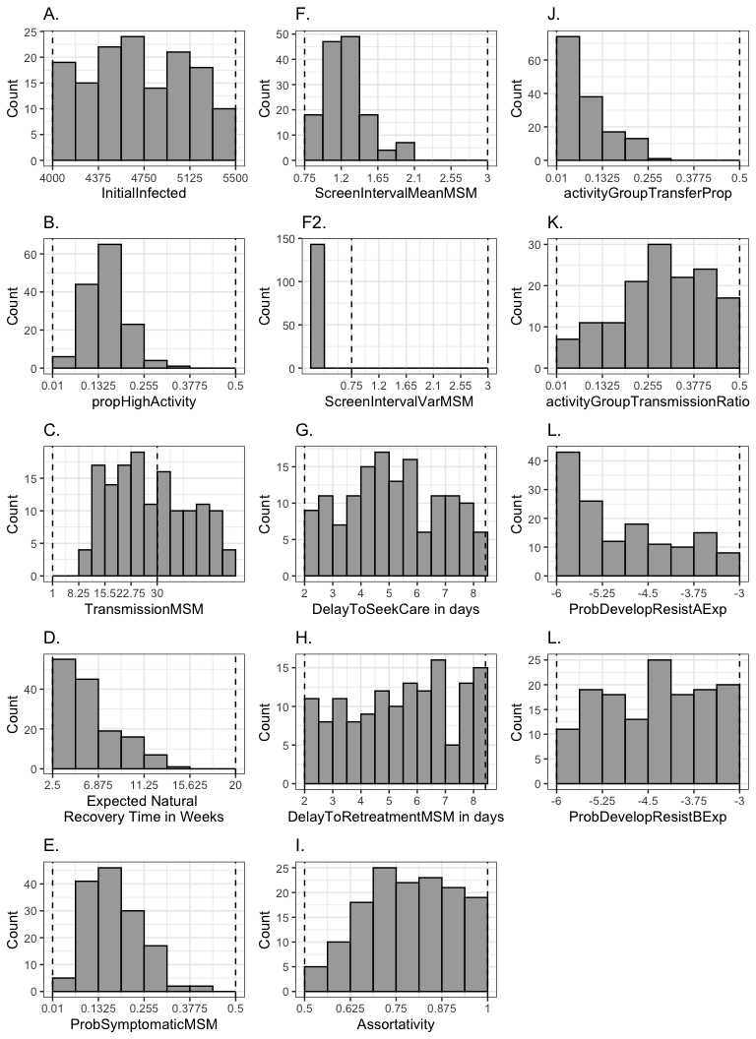

Figure S4, Transmission per infection per year
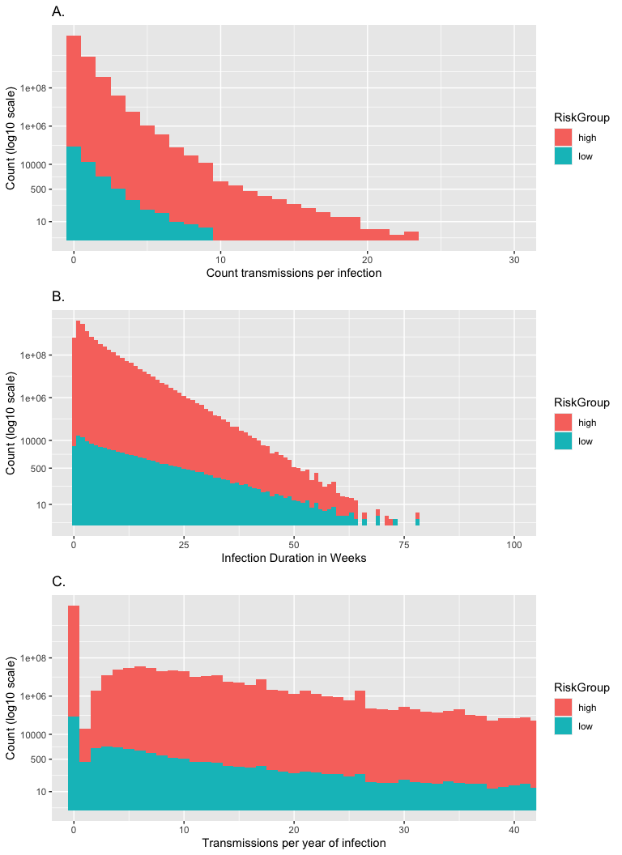

Table S1, parameter defs and prior distributions

Table S2, Cost parameters

Table S3, Sequelae-associated constants

Table S4, other QALY loss constants

Table S5, Goodness-of-fit Metrics
 | Calibration Target | Posterior estimate (mean) | Posterior 95% CI | Posterior 50% CI | Target Within 95% CI? | Target Within 50% CI? | Absolute Error | Relative Error (%) | Z-score | Posterior Predictive P-value | 95% CI Overlap
Prevalence | 4.50 | 3.70 | (1.91, 5.48) | (3.07, 4.31) | TRUE | FALSE | 0.80 | 17.72 | 0.84 | 0.19 | 1
Detected cases | 6508.00 | 9474.41 | (5608.10, 13692.40) | (7637.50, 11182.00) | TRUE | FALSE | 2966.41 | 45.58 | -1.34 | 0.91 | 1
Proportion detected cases symptomatic | 0.68 | 0.68 | (0.47, 0.79) | (0.63, 0.74) | TRUE | TRUE | 0.00 | 0.55 | 0.04 | 0.58 | 1

Table S6, PRCC table
Prevalence PRCC
 | var | est | lower | upper | test.statistic | df | p.value
1 | propHighActivity | 0.5357756 | 0.4663113 | 0.6052399 | 15.1492958 | 570 | 0.0000000
10 | activityGroupTransmissionRatio | 0.3149386 | 0.2368565 | 0.3930207 | 7.9222004 | 570 | 0.0000000
4 | ProbSymptomaticMSM | -0.3129983 | -0.3911332 | -0.2348635 | -7.8680749 | 570 | 0.0000000
8 | Assortativity | -0.2802949 | -0.3592656 | -0.2013242 | -6.9714058 | 570 | 0.0000000
3 | NaturalRecoveryTime | 0.2438874 | 0.1641031 | 0.3236717 | 6.0040326 | 570 | 0.0000000
7 | DelayToRetreatmentMSM | 0.2061534 | 0.1256520 | 0.2866548 | 5.0298884 | 570 | 0.0000007
2 | TransmissionMSM | 0.1775123 | 0.0965503 | 0.2584743 | 4.3064397 | 570 | 0.0000195
12 | BeginImportingB | -0.1483064 | -0.2296652 | -0.0669477 | -3.5803614 | 570 | 0.0003724
9 | activityGroupTransferProp | 0.0901527 | 0.0082191 | 0.1720862 | 2.1611659 | 570 | 0.0310983
11 | PercentResistantA | 0.0870685 | 0.0051124 | 0.1690246 | 2.0866569 | 570 | 0.0373630
18 | CareCost | -0.0833466 | -0.1653289 | -0.0013643 | -1.9968196 | 570 | 0.0463198
14 | ProbDevelopResistanceAExponent | 0.0785145 | -0.0035000 | 0.1605291 | 1.8803135 | 570 | 0.0605750
20 | StrainTestCost | 0.0783632 | -0.0036524 | 0.1603787 | 1.8766662 | 570 | 0.0610745
15 | ProbDevelopResistanceBExponent | -0.0765313 | -0.1585585 | 0.0054960 | -1.8325333 | 570 | 0.0673935
6 | DelayToSeekCareMSM | 0.0725909 | -0.0094606 | 0.1546424 | 1.7376676 | 570 | 0.0828095
24 | DrugETreatmentCost | -0.0695908 | -0.1516599 | 0.0124783 | -1.6654963 | 570 | 0.0963632
13 | ImportingBInterval | -0.0607922 | -0.1429086 | 0.0213241 | -1.4540845 | 570 | 0.1464733
17 | DSTspecificity | -0.0506974 | -0.1328602 | 0.0314653 | -1.2119434 | 570 | 0.2260362
21 | DrugATreatmentCost | -0.0347169 | -0.1169358 | 0.0475021 | -0.8293537 | 570 | 0.4072515
5 | ScreenIntervalMeanMSM | 0.0261195 | -0.0561210 | 0.1083600 | 0.6238076 | 570 | 0.5330035
23 | DrugXTreatmentCost | -0.0252961 | -0.1075383 | 0.0569461 | -0.6041301 | 570 | 0.5459975
22 | DrugBTreatmentCost | -0.0052945 | -0.0875619 | 0.0769728 | -0.1264074 | 570 | 0.8994540
19 | TestCost | 0.0030007 | -0.0792675 | 0.0852689 | 0.0716408 | 570 | 0.9429129
16 | DSTsensitivity | 0.0008336 | -0.0814349 | 0.0831021 | 0.0199017 | 570 | 0.9841288

Incidence PRCC
 | var | est | lower | upper | test.statistic | df | p.value
1 | propHighActivity | 0.4809367 | 0.4088073 | 0.5530661 | 13.0962494 | 570 | 0.0000000
10 | activityGroupTransmissionRatio | 0.2969482 | 0.2183905 | 0.3755059 | 7.4244305 | 570 | 0.0000000
2 | TransmissionMSM | 0.2615189 | 0.1821134 | 0.3409243 | 6.4688026 | 570 | 0.0000000
7 | DelayToRetreatmentMSM | 0.2453743 | 0.1656209 | 0.3251278 | 6.0429750 | 570 | 0.0000000
4 | ProbSymptomaticMSM | -0.2309012 | -0.3109466 | -0.1508558 | -5.6657961 | 570 | 0.0000000
12 | BeginImportingB | -0.1447547 | -0.2261567 | -0.0633526 | -3.4927580 | 570 | 0.0005151
14 | ProbDevelopResistanceAExponent | 0.1311130 | 0.0495546 | 0.2126713 | 3.1575368 | 570 | 0.0016752
20 | StrainTestCost | 0.1043037 | 0.0224839 | 0.1861235 | 2.5038739 | 570 | 0.0125625
13 | ImportingBInterval | -0.0990749 | -0.1809387 | -0.0172111 | -2.3770768 | 570 | 0.0177795
3 | NaturalRecoveryTime | 0.0914356 | 0.0095117 | 0.1733596 | 2.1921788 | 570 | 0.0287702
5 | ScreenIntervalMeanMSM | -0.0793574 | -0.1613664 | 0.0026517 | -1.9006251 | 570 | 0.0578553
8 | Assortativity | -0.0754966 | -0.1575304 | 0.0065371 | -1.8076165 | 570 | 0.0711932
16 | DSTsensitivity | 0.0678843 | -0.0141944 | 0.1499631 | 1.6244636 | 570 | 0.1048297
11 | PercentResistantA | 0.0676720 | -0.0144079 | 0.1497520 | 1.6193596 | 570 | 0.1059230
18 | CareCost | -0.0621816 | -0.1442909 | 0.0199278 | -1.4874428 | 570 | 0.1374509
9 | activityGroupTransferProp | -0.0616475 | -0.1437596 | 0.0204646 | -1.4746188 | 570 | 0.1408671
21 | DrugATreatmentCost | -0.0591692 | -0.1412936 | 0.0229552 | -1.4151255 | 570 | 0.1575778
6 | DelayToSeekCareMSM | 0.0589416 | -0.0231839 | 0.1410672 | 1.4096631 | 570 | 0.1591846
17 | DSTspecificity | -0.0557577 | -0.1378983 | 0.0263829 | -1.3332712 | 570 | 0.1829754
15 | ProbDevelopResistanceBExponent | -0.0470475 | -0.1292249 | 0.0351300 | -1.1244887 | 570 | 0.2612791
24 | DrugETreatmentCost | -0.0469512 | -0.1291290 | 0.0352266 | -1.1221819 | 570 | 0.2622576
23 | DrugXTreatmentCost | -0.0139949 | -0.0962554 | 0.0682656 | -0.3341563 | 570 | 0.7383845
19 | TestCost | 0.0054775 | -0.0767899 | 0.0877448 | 0.1307744 | 570 | 0.8959999
22 | DrugBTreatmentCost | 0.0019779 | -0.0802904 | 0.0842463 | 0.0472228 | 570 | 0.9623522

Symptomatic Proportion PRCC
 | var | est | lower | upper | test.statistic | df | p.value
4 | ProbSymptomaticMSM | 0.7811887 | 0.7298288 | 0.8325485 | 29.8746953 | 570 | 0.0000000
7 | DelayToRetreatmentMSM | 0.3266165 | 0.2488598 | 0.4043732 | 8.2503361 | 570 | 0.0000000
6 | DelayToSeekCareMSM | 0.3124208 | 0.2342703 | 0.3905713 | 7.8519850 | 570 | 0.0000000
11 | PercentResistantA | 0.1905308 | 0.1097694 | 0.2712923 | 4.6337461 | 570 | 0.0000045
3 | NaturalRecoveryTime | -0.1812274 | -0.2621337 | -0.1003211 | -4.3995971 | 570 | 0.0000129
10 | activityGroupTransmissionRatio | 0.1454682 | 0.0640748 | 0.2268617 | 3.5103459 | 570 | 0.0004829
14 | ProbDevelopResistanceAExponent | 0.1410497 | 0.0596036 | 0.2224957 | 3.4015215 | 570 | 0.0007171
5 | ScreenIntervalMeanMSM | -0.1333486 | -0.2148824 | -0.0518148 | -3.2123423 | 570 | 0.0013908
13 | ImportingBInterval | -0.1269567 | -0.2085596 | -0.0453539 | -3.0557772 | 570 | 0.0023498
20 | StrainTestCost | 0.1261459 | 0.0445345 | 0.2077572 | 3.0359435 | 570 | 0.0025074
12 | BeginImportingB | -0.1195883 | -0.2012665 | -0.0379102 | -2.8757696 | 570 | 0.0041811
17 | DSTspecificity | 0.0955145 | 0.0136221 | 0.1774070 | 2.2908523 | 570 | 0.0223361
19 | TestCost | 0.0791859 | -0.0028243 | 0.1611961 | 1.8964931 | 570 | 0.0584002
8 | Assortativity | -0.0643401 | -0.1464381 | 0.0177580 | -1.5392873 | 570 | 0.1242891
23 | DrugXTreatmentCost | 0.0574627 | -0.0246699 | 0.1395953 | 1.3741733 | 570 | 0.1699280
9 | activityGroupTransferProp | -0.0566391 | -0.1387756 | 0.0254974 | -1.3544139 | 570 | 0.1761410
18 | CareCost | -0.0520423 | -0.1341993 | 0.0301148 | -1.2441782 | 570 | 0.2139454
16 | DSTsensitivity | 0.0478230 | -0.0343514 | 0.1299974 | 1.1430671 | 570 | 0.2534906
15 | ProbDevelopResistanceBExponent | -0.0466465 | -0.1288255 | 0.0355325 | -1.1148844 | 570 | 0.2653698
21 | DrugATreatmentCost | -0.0387560 | -0.1209627 | 0.0434507 | -0.9259826 | 570 | 0.3548469
22 | DrugBTreatmentCost | 0.0317459 | -0.0504812 | 0.1139730 | 0.7583046 | 570 | 0.4485821
1 | propHighActivity | -0.0234385 | -0.1056844 | 0.0588074 | -0.5597404 | 570 | 0.5758764
24 | DrugETreatmentCost | -0.0168251 | -0.0990820 | 0.0654318 | -0.4017514 | 570 | 0.6880176
2 | TransmissionMSM | -0.0139029 | -0.0961635 | 0.0683577 | -0.3319596 | 570 | 0.7400418

Costs PRCC
 | var | est | lower | upper | test.statistic | df | p.value
1 | propHighActivity | 0.3677739 | 0.2912711 | 0.4442766 | 9.4422374 | 570 | 0.0000000
10 | activityGroupTransmissionRatio | 0.2686963 | 0.1894532 | 0.3479394 | 6.6599572 | 570 | 0.0000000
4 | ProbSymptomaticMSM | 0.1949305 | 0.1142402 | 0.2756209 | 4.7449245 | 570 | 0.0000026
2 | TransmissionMSM | 0.1529104 | 0.0716093 | 0.2342114 | 3.6941279 | 570 | 0.0002419
8 | Assortativity | -0.1480629 | -0.2294247 | -0.0667012 | -3.5743509 | 570 | 0.0003809
5 | ScreenIntervalMeanMSM | -0.1467079 | -0.2280862 | -0.0653295 | -3.5409153 | 570 | 0.0004313
7 | DelayToRetreatmentMSM | 0.1355313 | 0.0540219 | 0.2170408 | 3.2659007 | 570 | 0.0011567
11 | PercentResistantA | 0.1329678 | 0.0514297 | 0.2145058 | 3.2030037 | 570 | 0.0014359
14 | ProbDevelopResistanceAExponent | 0.1179799 | 0.0362859 | 0.1996739 | 2.8365417 | 570 | 0.0047226
3 | NaturalRecoveryTime | 0.1135375 | 0.0318010 | 0.1952741 | 2.7283135 | 570 | 0.0065623
12 | BeginImportingB | -0.1056466 | -0.1874547 | -0.0238384 | -2.5364720 | 570 | 0.0114633
13 | ImportingBInterval | -0.0817235 | -0.1637169 | 0.0002698 | -1.9576710 | 570 | 0.0507562
9 | activityGroupTransferProp | -0.0725992 | -0.1546506 | 0.0094523 | -1.7378675 | 570 | 0.0827742
20 | StrainTestCost | 0.0689611 | -0.0131116 | 0.1510338 | 1.6503533 | 570 | 0.0994216
19 | TestCost | 0.0641297 | -0.0179695 | 0.1462289 | 1.5342342 | 570 | 0.1255269
16 | DSTsensitivity | 0.0579872 | -0.0241430 | 0.1401173 | 1.3867577 | 570 | 0.1660577
15 | ProbDevelopResistanceBExponent | -0.0548193 | -0.1369641 | 0.0273256 | -1.3107633 | 570 | 0.1904656
18 | CareCost | -0.0240234 | -0.1062682 | 0.0582214 | -0.5737174 | 570 | 0.5663854
17 | DSTspecificity | -0.0137530 | -0.0960138 | 0.0685077 | -0.3283801 | 570 | 0.7427449
23 | DrugXTreatmentCost | 0.0122955 | -0.0699669 | 0.0945578 | 0.2935726 | 570 | 0.7691914
24 | DrugETreatmentCost | -0.0114478 | -0.0937109 | 0.0708154 | -0.2733293 | 570 | 0.7846991
22 | DrugBTreatmentCost | 0.0102498 | -0.0720144 | 0.0925141 | 0.2447245 | 570 | 0.8067578
21 | DrugATreatmentCost | -0.0098988 | -0.0921633 | 0.0723657 | -0.2363423 | 570 | 0.8132520
6 | DelayToSeekCareMSM | 0.0082964 | -0.0739693 | 0.0905621 | 0.1980800 | 570 | 0.8430531

QALYs PRCC
 | var | est | lower | upper | test.statistic | df | p.value
4 | ProbSymptomaticMSM | 0.4301027 | 0.3558323 | 0.5043731 | 11.3743800 | 570 | 0.0000000
1 | propHighActivity | 0.3691540 | 0.2926962 | 0.4456117 | 9.4832483 | 570 | 0.0000000
10 | activityGroupTransmissionRatio | 0.2910384 | 0.2123311 | 0.3697456 | 7.2628439 | 570 | 0.0000000
7 | DelayToRetreatmentMSM | 0.2636135 | 0.1842549 | 0.3429721 | 6.5244673 | 570 | 0.0000000
6 | DelayToSeekCareMSM | 0.2344239 | 0.1544479 | 0.3144000 | 5.7572229 | 570 | 0.0000000
8 | Assortativity | -0.1647268 | -0.2458714 | -0.0835821 | -3.9872664 | 570 | 0.0000755
11 | PercentResistantA | 0.1472586 | 0.0658869 | 0.2286302 | 3.5545015 | 570 | 0.0004101
2 | TransmissionMSM | 0.1412998 | 0.0598567 | 0.2227429 | 3.4076763 | 570 | 0.0007014
14 | ProbDevelopResistanceAExponent | 0.1172409 | 0.0355397 | 0.1989421 | 2.8185262 | 570 | 0.0049920
12 | BeginImportingB | -0.1120571 | -0.1938075 | -0.0303067 | -2.6922841 | 570 | 0.0073051
20 | StrainTestCost | 0.1061378 | 0.0243340 | 0.1879417 | 2.5484010 | 570 | 0.0110829
13 | ImportingBInterval | -0.0953246 | -0.1772185 | -0.0134307 | -2.2862546 | 570 | 0.0226053
9 | activityGroupTransferProp | -0.0814106 | -0.1634061 | 0.0005848 | -1.9501250 | 570 | 0.0516510
18 | CareCost | -0.0688196 | -0.1508930 | 0.0132539 | -1.6469490 | 570 | 0.1001197
3 | NaturalRecoveryTime | 0.0600377 | -0.0220825 | 0.1421578 | 1.4359700 | 570 | 0.1515594
15 | ProbDevelopResistanceBExponent | -0.0545402 | -0.1366863 | 0.0276059 | -1.3040707 | 570 | 0.1927358
16 | DSTsensitivity | 0.0529982 | -0.0291548 | 0.1351511 | 1.2670943 | 570 | 0.2056390
5 | ScreenIntervalMeanMSM | -0.0513947 | -0.1335545 | 0.0307652 | -1.2286543 | 570 | 0.2197085
21 | DrugATreatmentCost | -0.0343985 | -0.1166184 | 0.0478213 | -0.8217398 | 570 | 0.4115686
24 | DrugETreatmentCost | -0.0203039 | -0.1025555 | 0.0619477 | -0.4848492 | 570 | 0.6279696
17 | DSTspecificity | 0.0176490 | -0.0646067 | 0.0999047 | 0.4214300 | 570 | 0.6736000
22 | DrugBTreatmentCost | 0.0152978 | -0.0669611 | 0.0975568 | 0.3652735 | 570 | 0.7150427
23 | DrugXTreatmentCost | 0.0149991 | -0.0672602 | 0.0972584 | 0.3581387 | 570 | 0.7203721
19 | TestCost | 0.0137720 | -0.0684887 | 0.0960328 | 0.3288341 | 570 | 0.7424019

Supplement 2, ODD

Table S6, Model entities

Supplement 3, CHEERS Checklist

Supplement 4, Sensitivity analysis

Figure S5, drug X availability summary results
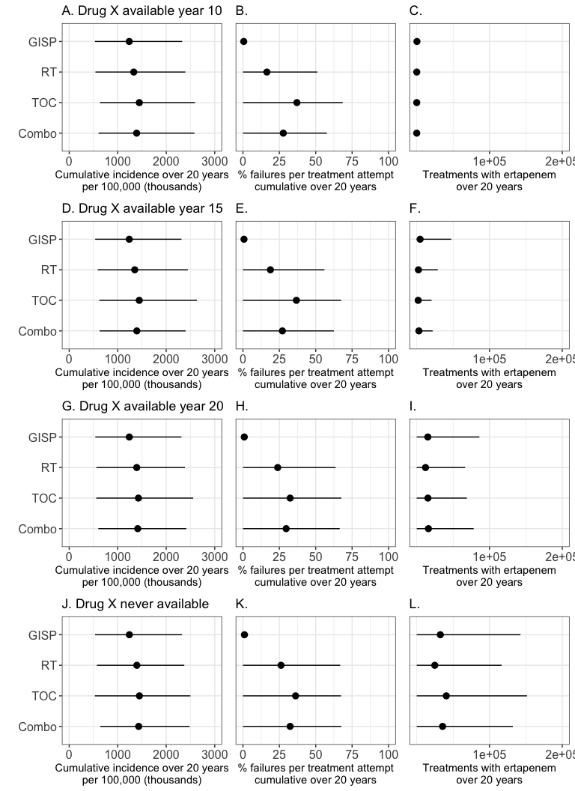

Figure S6, yearX = 10, trends over time
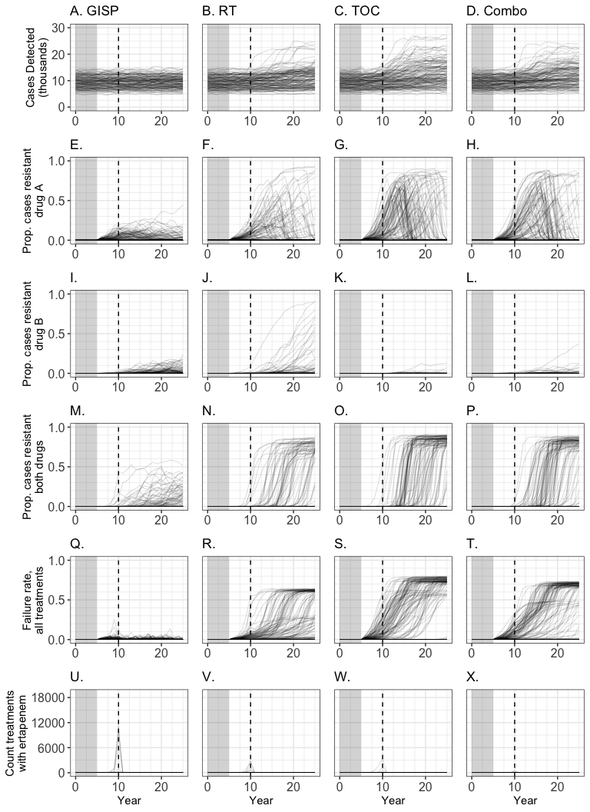

Figure S7, yearX = 15, trends over time
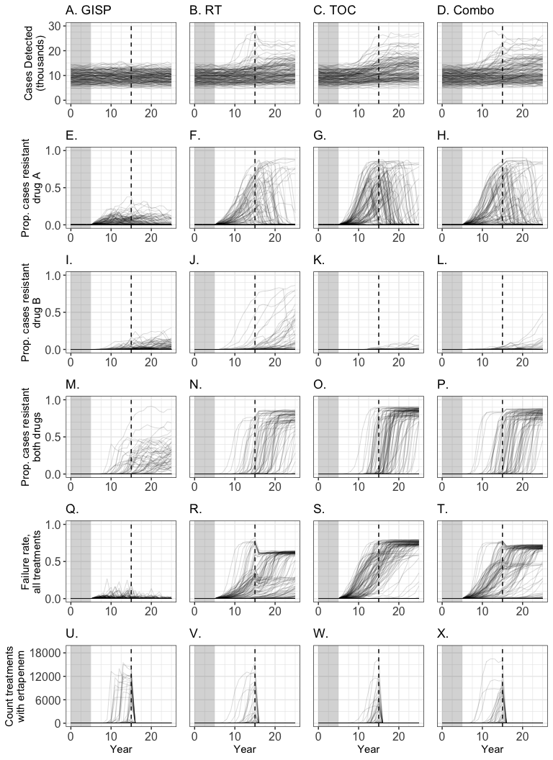

Figure S8, never drug X, trends over time
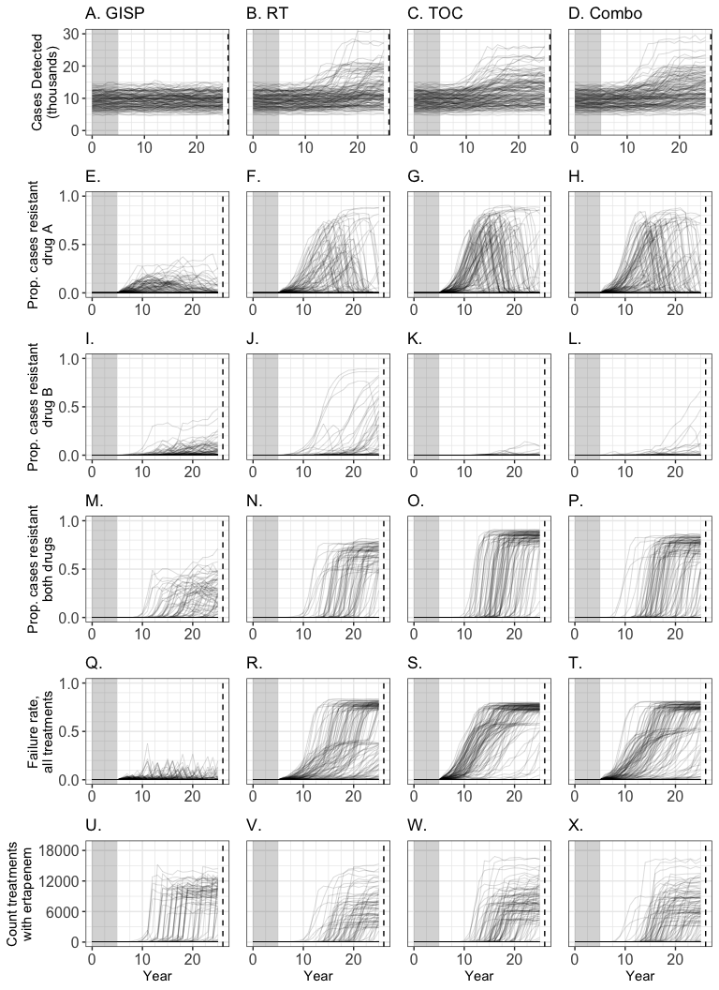

Figure S9, CEA under different drug X availability
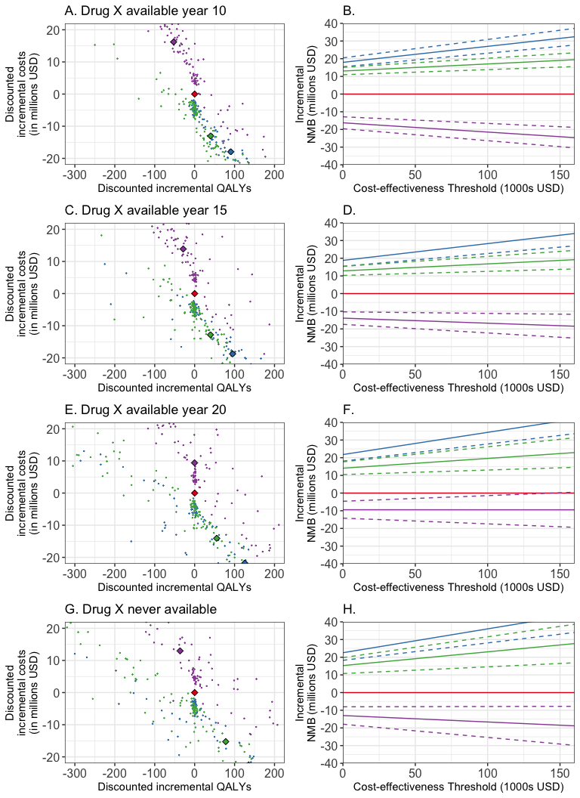

Figure S10, varying GISP switchpoint summary results
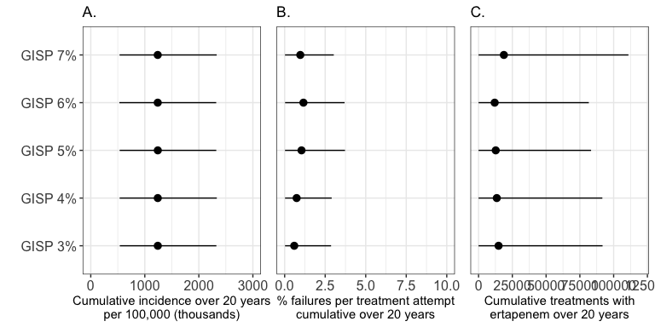

Figure S11, varying GISP switchpoint CEA results
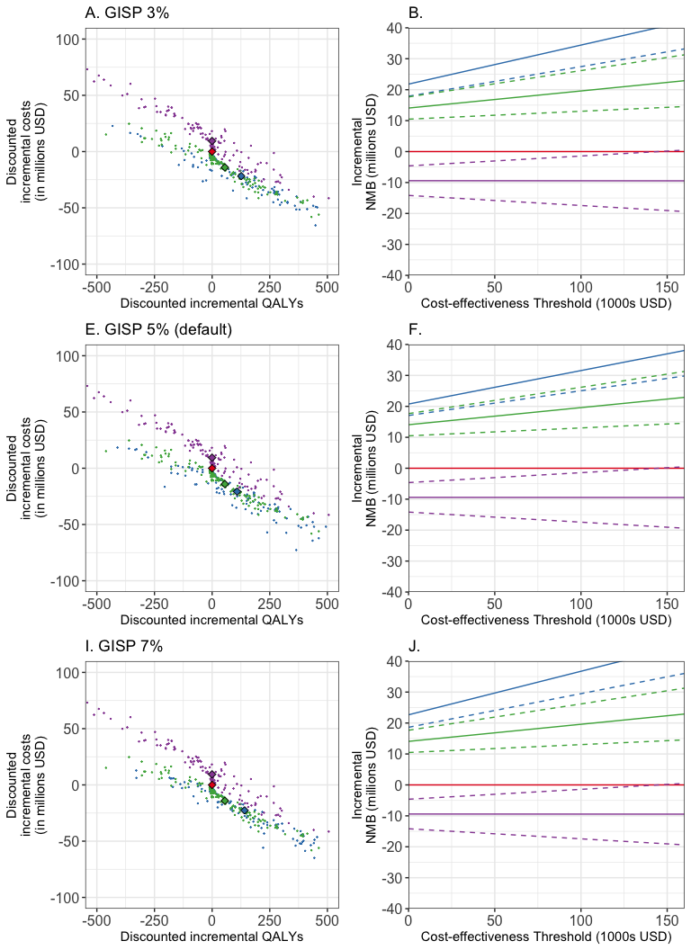

Figure S12, symptomatic adherence to TOC, summary results
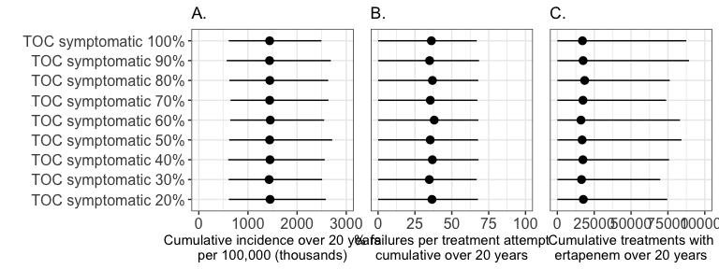

Figure S13, symptomatic adherence to TOC, CEA results
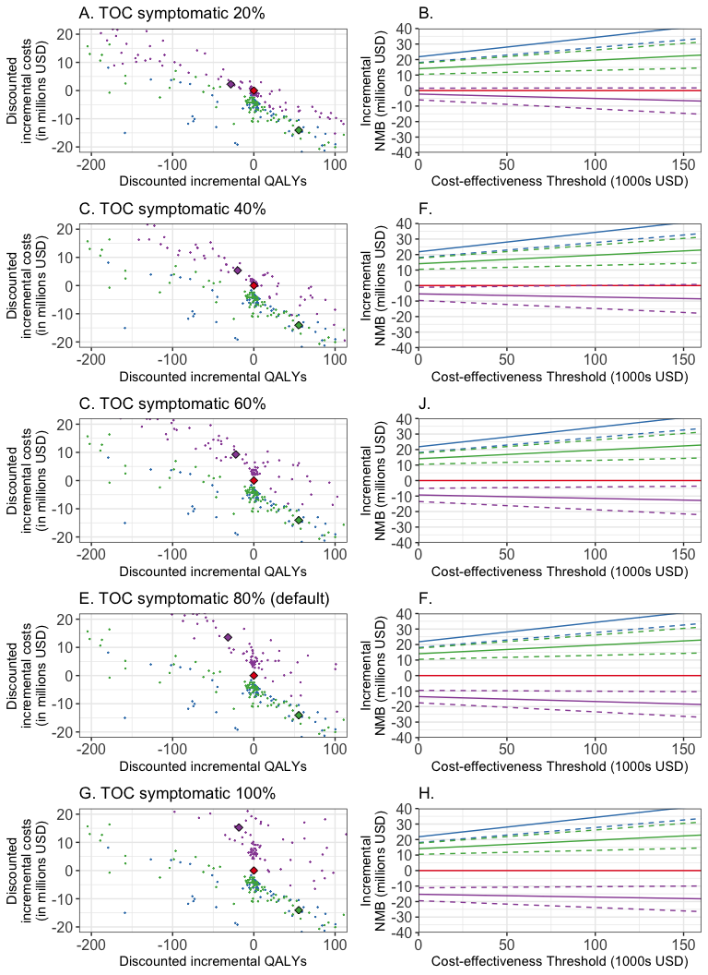

Figure S14, asymptomatic adherence to TOC, summary results
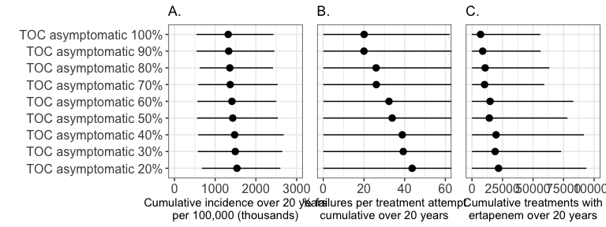

Figure S15, asymptomatic adherence to TOC, CEA results
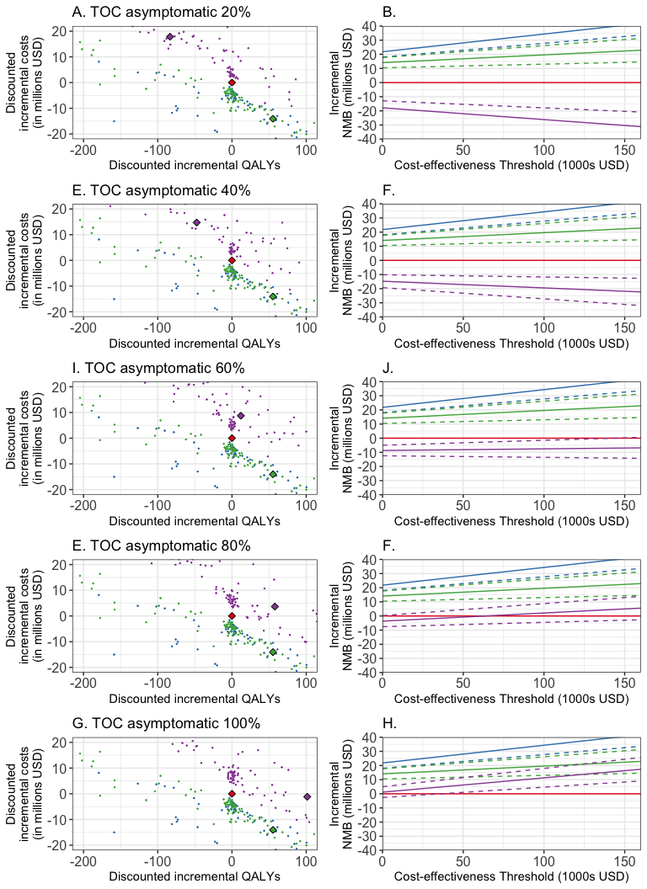

Figure S16, combo sensitivity analysis, summary results
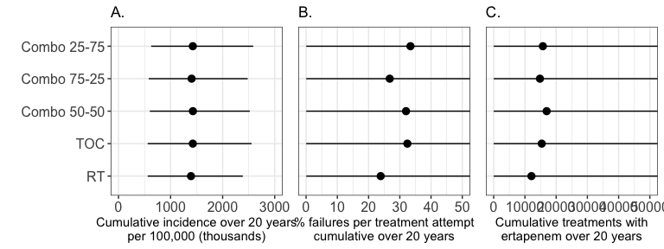

Figure S17, combo sensitivity analysis, CEA results
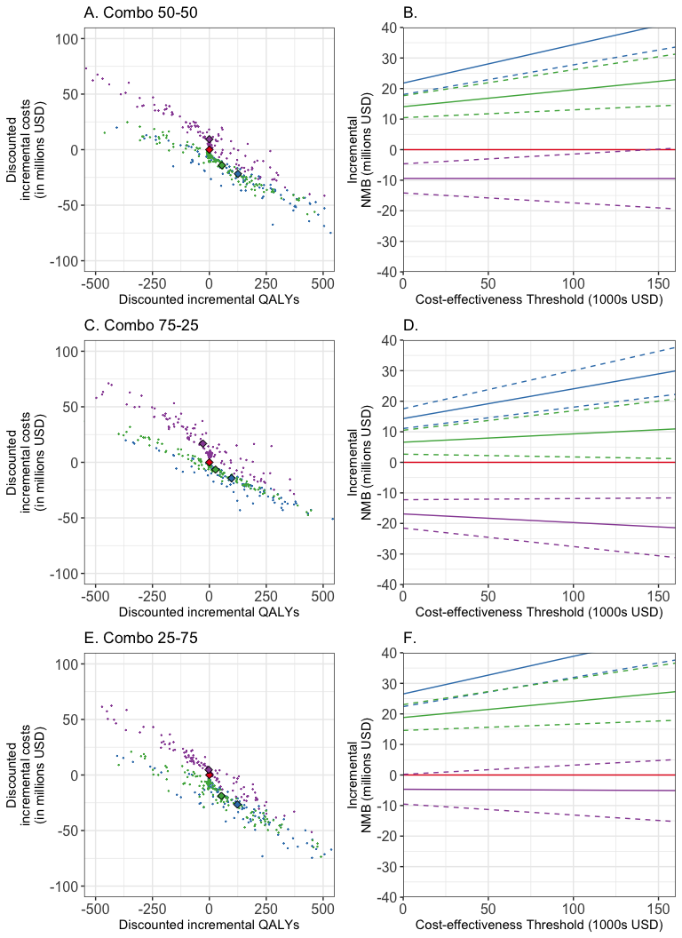

Supplement 5 rDST and MT

Table S7, sensitivity and specificity parameters for rDST

Figure S18, model diagram for rDST counterfactual
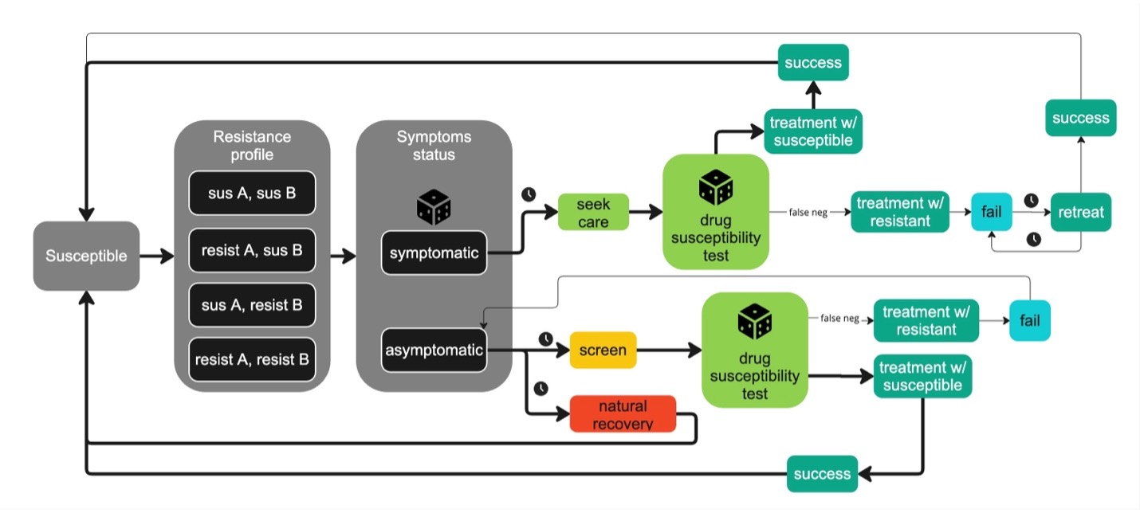
Figure S18.

Figure S19, Model diagram for MT counterfactual (combo which includes rDST)
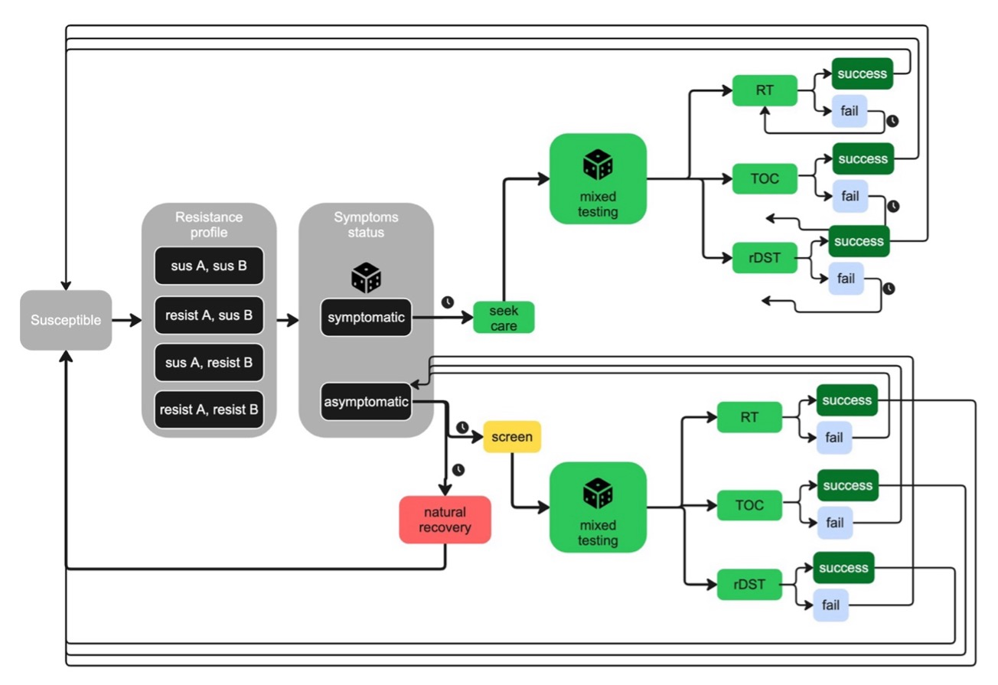
Figure S19.

Figure S20, impact of rDST on a given strain, given sensitivity and specificity
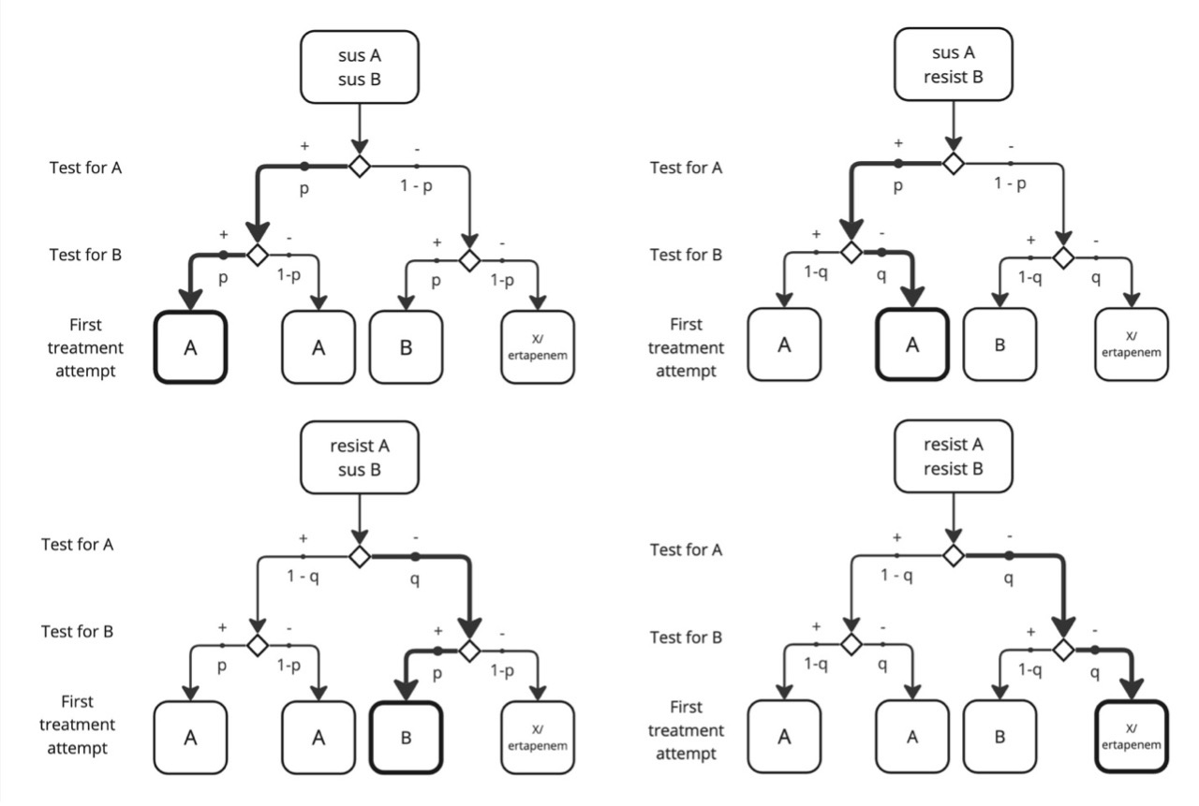
Figure S20.

Table S8, Results table with rDST and MT
#supplement tables for rDST and MT
summary_DST <- cumulative_everything(dfDST80)
summary_MT <- cumulative_everything(dfRC45_45_10)
#incidence
mean(summary_DST$cumulativeInc)
## [1] 1276299
quantile(summary_DST$cumulativeInc, probs = c(0.025, 0.975))
## 2.5% 97.5%
## 546485 2329807
mean(summary_MT$cumulativeInc)
## [1] 1365694
quantile(summary_MT$cumulativeInc, probs = c(0.025, 0.975))
## 2.5% 97.5%
## 582049.4 2404030.9
#resistant incidence
mean(summary_DST$cumulativeResist)
## [1] 339381.2
quantile(summary_DST$cumulativeResist, probs = c(0.025, 0.975))
## 2.5% 97.5%
## 260.3 1888462.6
mean(summary_MT$cumulativeResist)
## [1] 458542.8
quantile(summary_MT$cumulativeResist, probs = c(0.025, 0.975))
## 2.5% 97.5%
## 278.55 1741514.20
#failure
mean(summary_DST$cumulativeFailure*100)
## [1] 7.383266
quantile(summary_DST$cumulativeFailure*100, probs = c(0.025, 0.975))
## 2.5% 97.5%
## 0.01117407 32.69021804
mean(summary_MT$cumulativeFailure*100)
## [1] 21.93818
quantile(summary_MT$cumulativeFailure*100, probs = c(0.025, 0.975))
## 2.5% 97.5%
## 0.02295343 60.14444857
#ertapenem
mean(summary_DST$cumulativeE)
## [1] 12515.67
quantile(summary_DST$cumulativeE, probs = c(0.025, 0.975))
## 2.5% 97.5%
## 47.1 122199.6
mean(summary_MT$cumulativeE)
## [1] 13219.56
quantile(summary_MT$cumulativeE, probs = c(0.025, 0.975))
## 2.5% 97.5%
## 5.55 68828.85

Table S9, CEA table with rDST and MT
#cost
mean(summary_DST$cumulativeCosts) / 1000000
## [1] 70.42223
quantile(summary_DST$cumulativeCosts/ 1000000, probs = c(0.025, 0.975))
## 2.5% 97.5%
## 39.3353 115.6806
mean(summary_MT$cumulativeCosts) / 1000000
## [1] 61.28823
quantile(summary_MT$cumulativeCosts/ 1000000, probs = c(0.025, 0.975))
## 2.5% 97.5%
## 29.12975 127.36072
#QALYs
mean(summary_DST$cumulativeQALYs)
## [1] 412.1704
quantile(summary_DST$cumulativeQALYs, probs = c(0.025, 0.975))
## 2.5% 97.5%
## 168.9062 1084.8192
mean(summary_MT$cumulativeQALYs)
## [1] 469.9242
quantile(summary_MT$cumulativeQALYs, probs = c(0.025, 0.975))
## 2.5% 97.5%
## 175.0766 1161.6440
ceatable_w_DST <- cea_real_unweighted(dfRC45_45_10, dfGISP25, dfrandom25, dfTOC25, dfDST80)
ceatable_w_DST$IncrementalCostsMTtoGISP <- ceatable_w_DST$GISPcumulativeCosts - ceatable_w_DST$RCcumulativeCosts
ceatable_w_DST$IncrementalCostsGISPtoRT <- ceatable_w_DST$RandomcumulativeCosts - ceatable_w_DST$GISPcumulativeCosts
ceatable_w_DST$IncrementalCostsRTtoTOC <- ceatable_w_DST$TOCcumulativeCosts - ceatable_w_DST$RandomcumulativeCosts
ceatable_w_DST$IncrementalCostsTOCtoDST <- ceatable_w_DST$DSTcumulativeCosts - ceatable_w_DST$TOCcumulativeCosts
ceatable_w_DST$IncrementalCostsGISPtoDST <- ceatable_w_DST$DSTcumulativeCosts - ceatable_w_DST$GISPcumulativeCosts
mean(ceatable_w_DST$IncrementalCostsMTtoGISP) / 1000000
## [1] -18.0835
quantile(ceatable_w_DST$IncrementalCostsMTtoGISP, probs = c(0.025, 0.975)) / 1000000
## 2.5% 97.5%
## -71.361465 9.154755
mean(ceatable_w_DST$IncrementalCostsGISPtoRT) / 1000000
## [1] 7.722486
quantile(ceatable_w_DST$IncrementalCostsGISPtoRT, probs = c(0.025, 0.975)) / 1000000
## 2.5% 97.5%
## -16.53422 40.24117
mean(ceatable_w_DST$IncrementalCostsRTtoTOC) / 1000000
## [1] 23.46895
quantile(ceatable_w_DST$IncrementalCostsRTtoTOC, probs = c(0.025, 0.975)) / 1000000
## 2.5% 97.5%
## -19.56706 96.18329
mean(ceatable_w_DST$IncrementalCostsTOCtoDST) / 1000000
## [1] -3.973932
quantile(ceatable_w_DST$IncrementalCostsTOCtoDST, probs = c(0.025, 0.975)) / 1000000
## 2.5% 97.5%
## -76.47588 54.46639
mean(ceatable_w_DST$IncrementalCostsGISPtoDST) / 1000000
## [1] 27.21751
quantile(ceatable_w_DST$IncrementalCostsGISPtoDST, probs = c(0.025, 0.975)) / 1000000
## 2.5% 97.5%
## 3.275732 75.731129
ceatable_w_DST$IncrementalQALYsMTtoGISP <- ceatable_w_DST$GISPcumulativeQALYs - ceatable_w_DST$RCcumulativeQALYs
ceatable_w_DST$IncrementalQALYsGISPtoDST <- ceatable_w_DST$DSTcumulativeQALYs - ceatable_w_DST$GISPcumulativeQALYs
mean(ceatable_w_DST$IncrementalQALYsMTtoGISP)
## [1] -69.93091
quantile(ceatable_w_DST$IncrementalQALYsMTtoGISP, probs = c(0.025, 0.975))
## 2.5% 97.5%
## -609.2708 282.0677
mean(ceatable_w_DST$IncrementalQALYsGISPtoDST)
## [1] 12.17719
quantile(ceatable_w_DST$IncrementalQALYsGISPtoDST, probs = c(0.025, 0.975))
## 2.5% 97.5%
## -385.7836 696.1098
ceatable_w_DST$ICERGISPtoDST <- ceatable_w_DST$IncrementalCostsGISPtoDST / (-ceatable_w_DST$IncrementalQALYsGISPtoDST)
mean(ceatable_w_DST$ICERGISPtoDST) / 1000000
## [1] -1.836917
quantile(ceatable_w_DST$ICERGISPtoDST, probs = c(0.025, 0.975)) /1000000
## 2.5% 97.5%
## -48.62389 25.32397

Figure S21, varying rDST summary figure
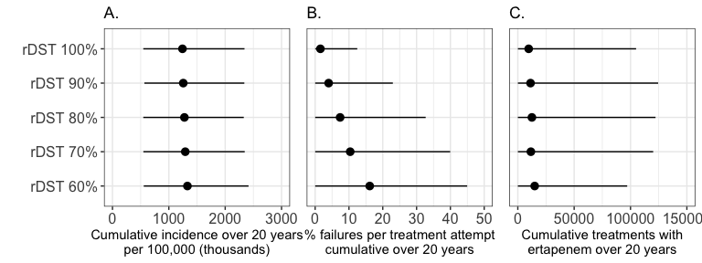

Figure S22, varying rDST CEA figure
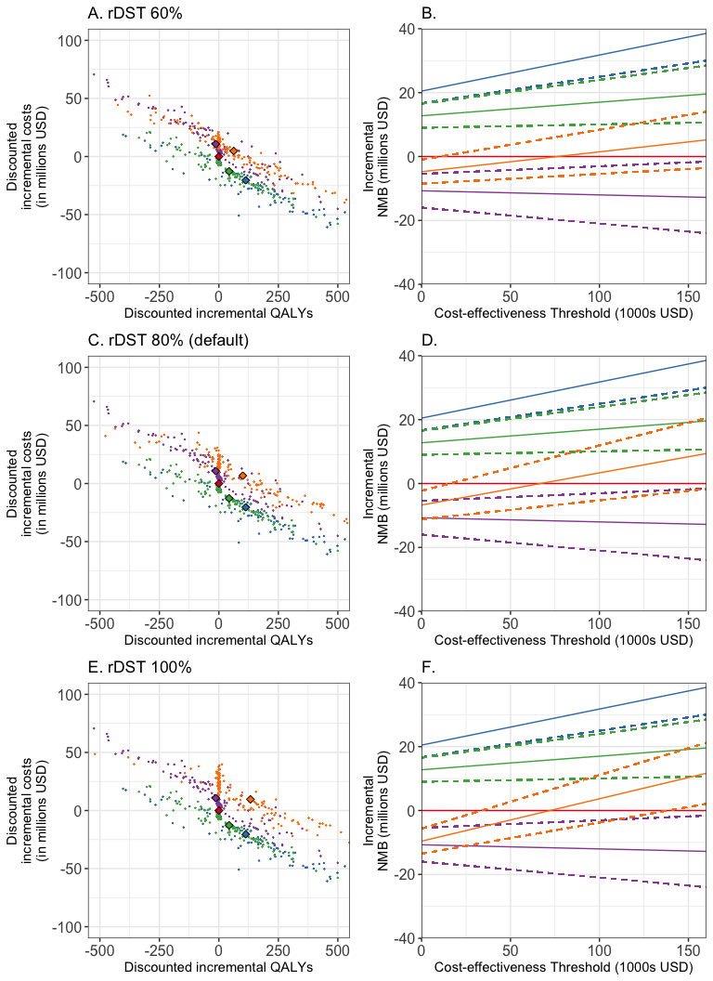

Figure S23, varying MT summary figure
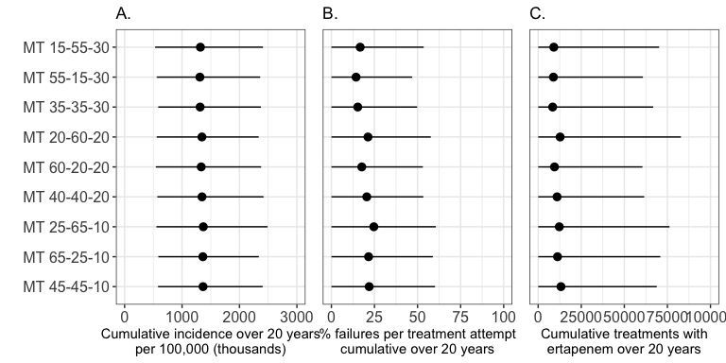

Figure S24, varying MT CEA figure
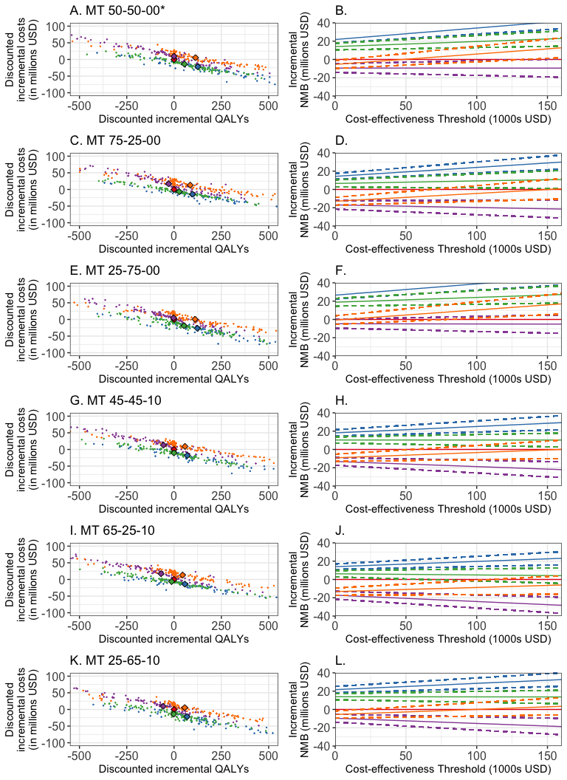

Supplement 6 Screening Heterogeneity (not updating)

Figure S25, posterior distributions
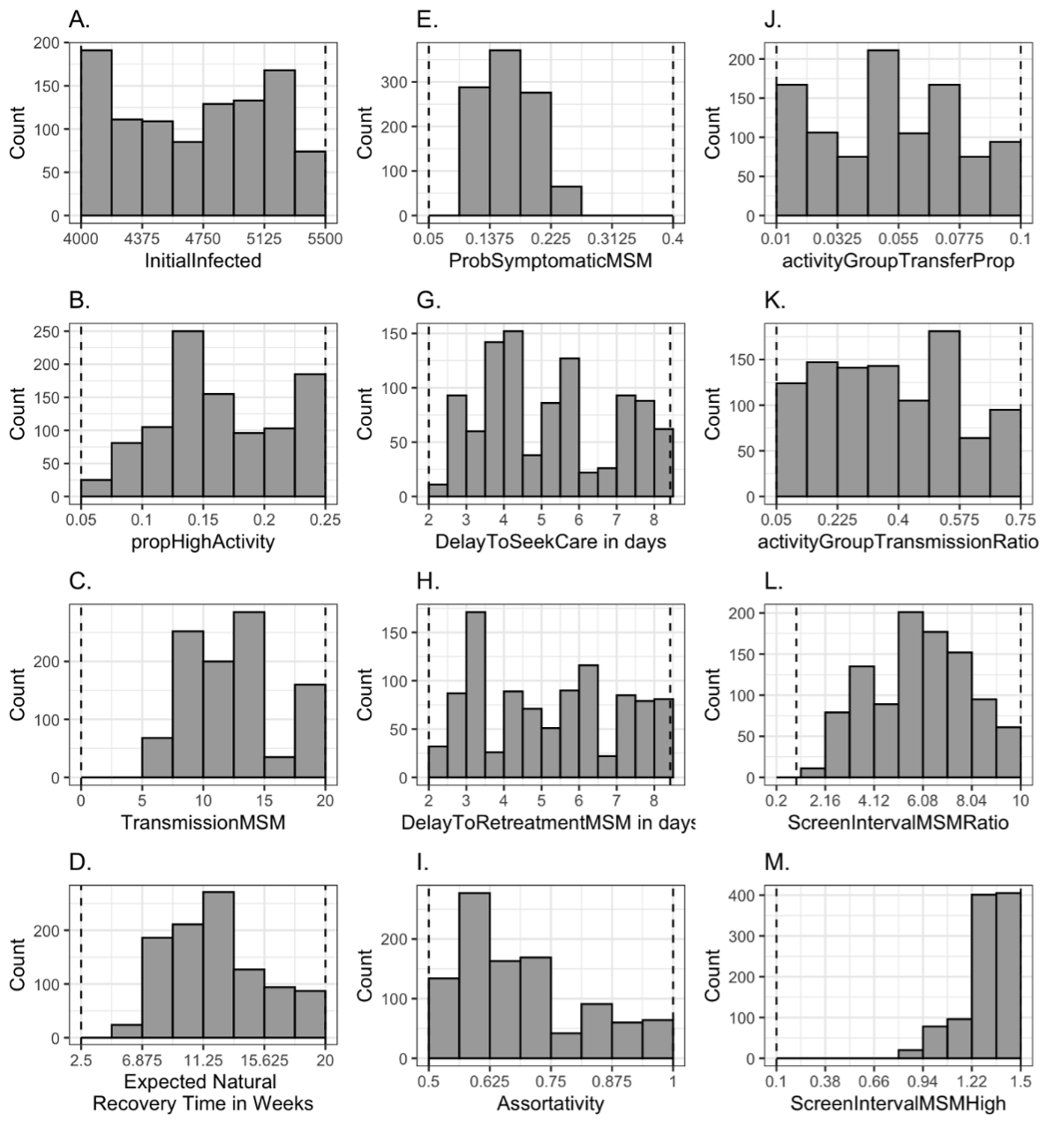
Figure S20.

Figure S26, calibrated trajectories
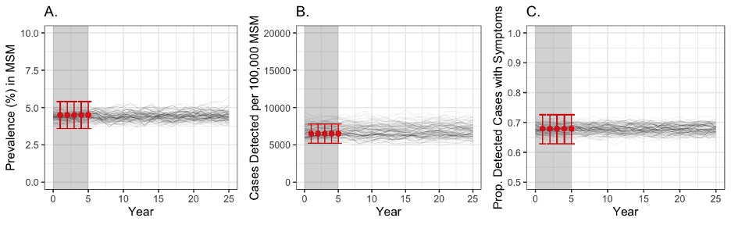
Figure S20.

Figure S27, summary results
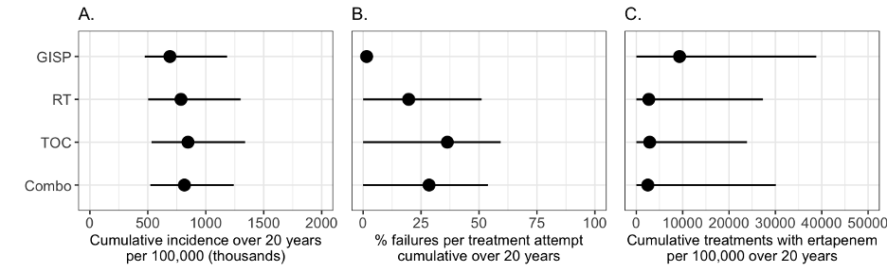
Figure S20.

Figure S28, trends over time
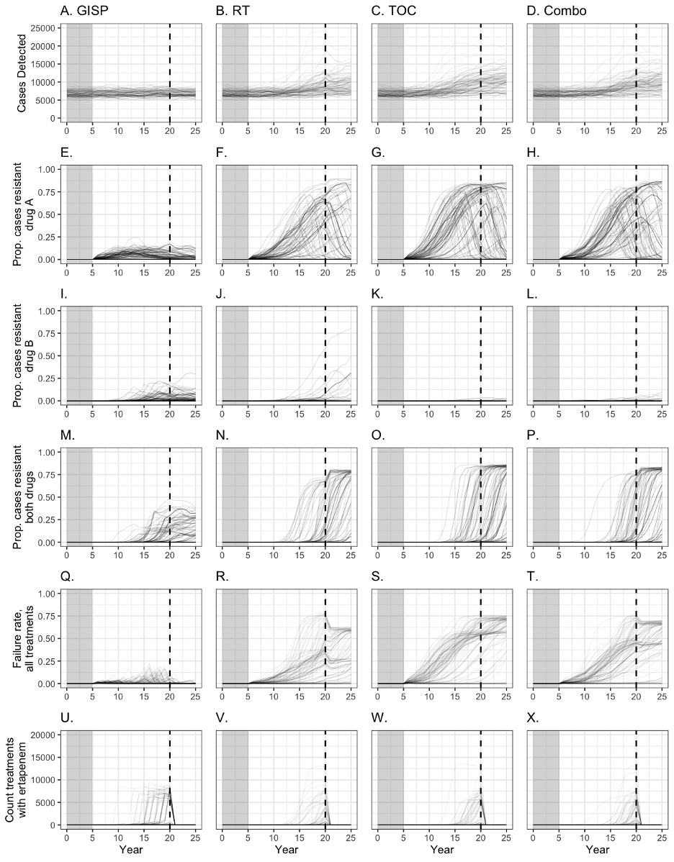
Figure S20.

Figure S29, CEA figure
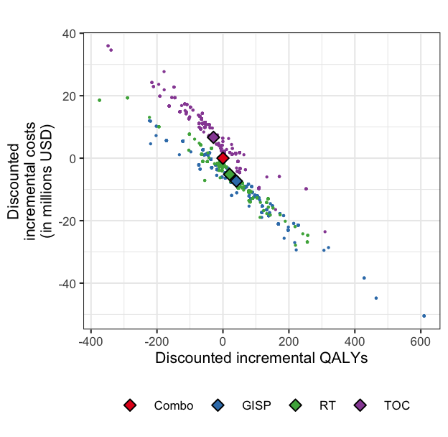
Figure S20.

Table S10, main results table

Table S11, CEA results table
#Supplement 7 Fitness Costs

Figure S30
 Figure S30. Summary plot when fitness costs were 0%. Identical to figure 3 in main text.

Figure S31
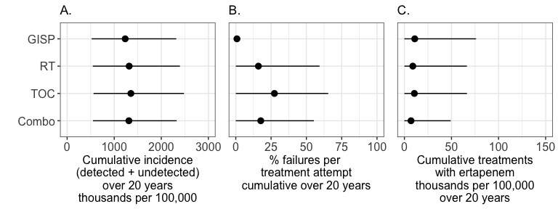 Figure S31. Summary plot when fitness costs were 1% for both strain resistant to drug A and strain resistant to drug B.

Figure S32
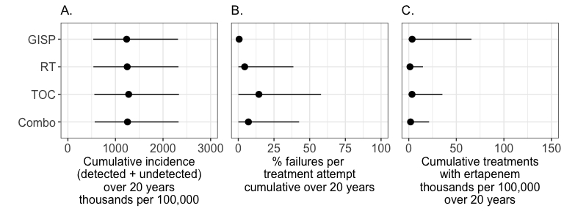 Figure S32. Summary plot when fitness costs were 2.5% for both strain resistant to drug A and strain resistant to drug B.

Figure S33
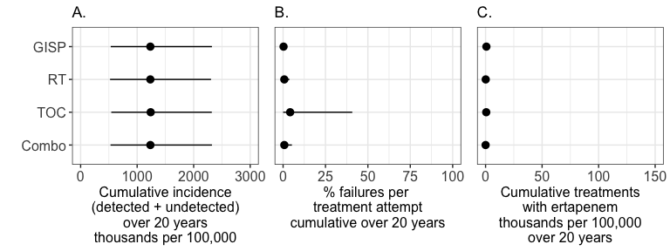 Figure S33. Summary plot when fitness costs were 5% for both strain resistant to drug A and strain resistant to drug B.

Figure S34
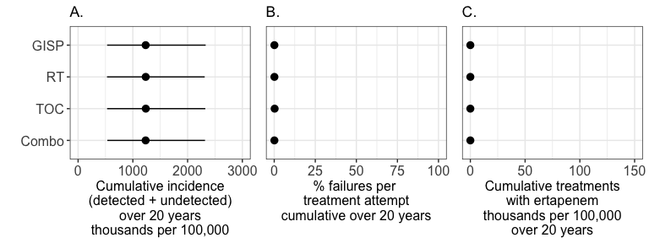 Figure S34. Summary plot when fitness costs were 10% for both strain resistant to drug A and strain resistant to drug B.

Figure S35
 Figure S35. Trends in incidence and resistance when fitness costs were 0%. Identical to figure 4 in main text.

Figure S36
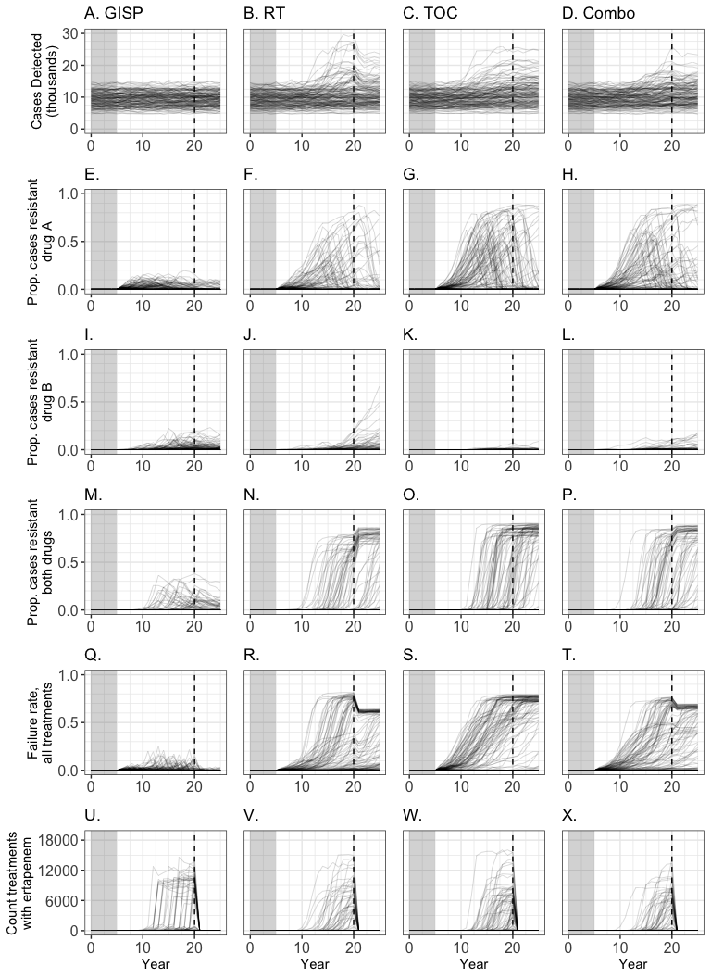 Figure S36. Trends in incidence and resistance when fitness costs were 1%for both strain resistant to drug A and strain resistant to drug B.

Figure S37
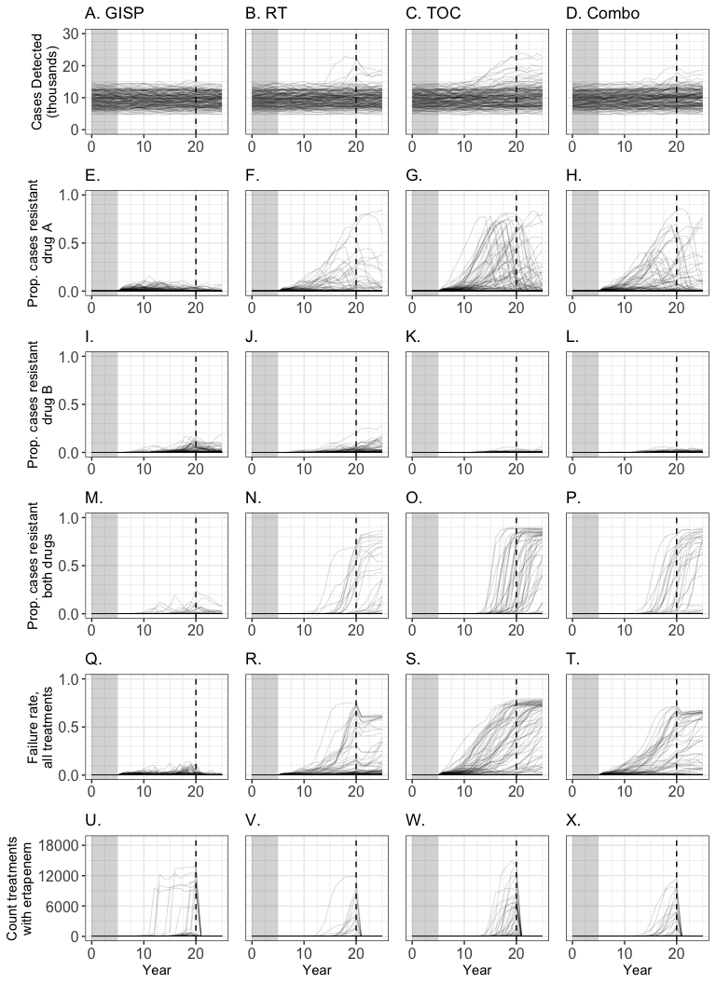 Figure S37. Trends in incidence and resistance when fitness costs were 2.5% for both strain resistant to drug A and strain resistant to drug B.

Figure S38
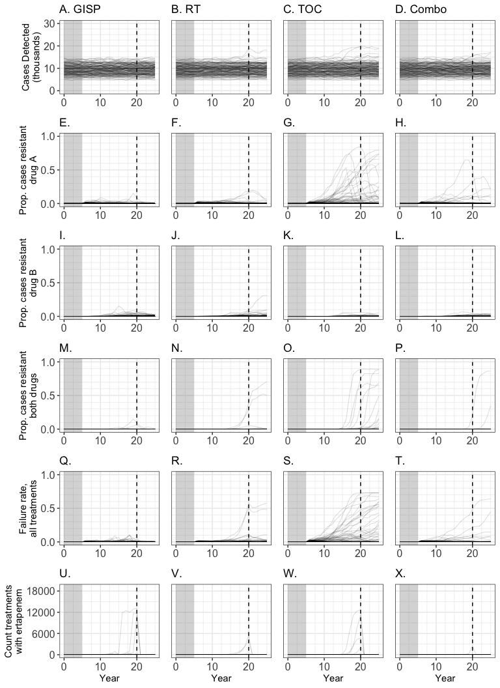 Figure S38. Trends in incidence and resistance when fitness costs were 5% for both strain resistant to drug A and strain resistant to drug B.

Figure S39
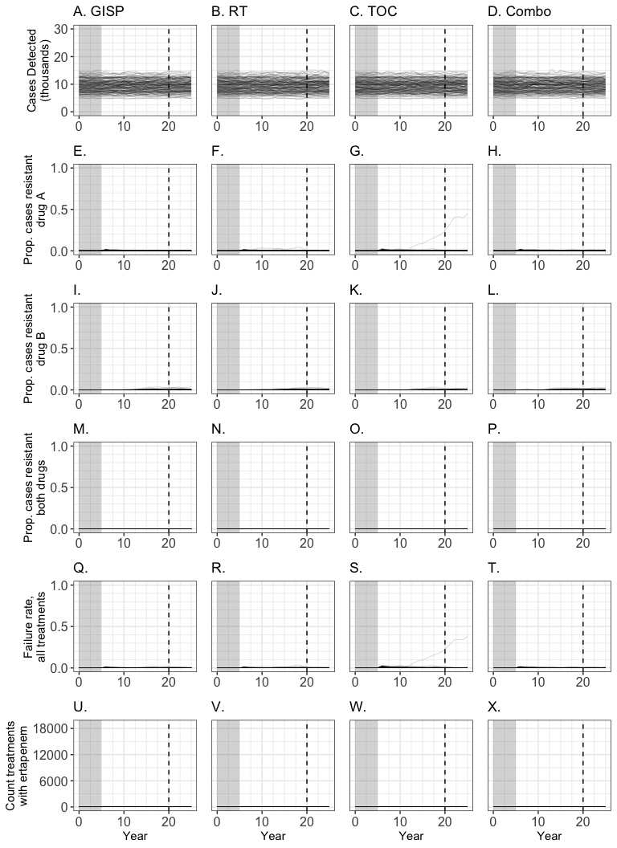 Figure S39. Trends in incidence and resistance when fitness costs were 10% for both strain resistant to drug A and strain resistant to drug B.

Figure S40
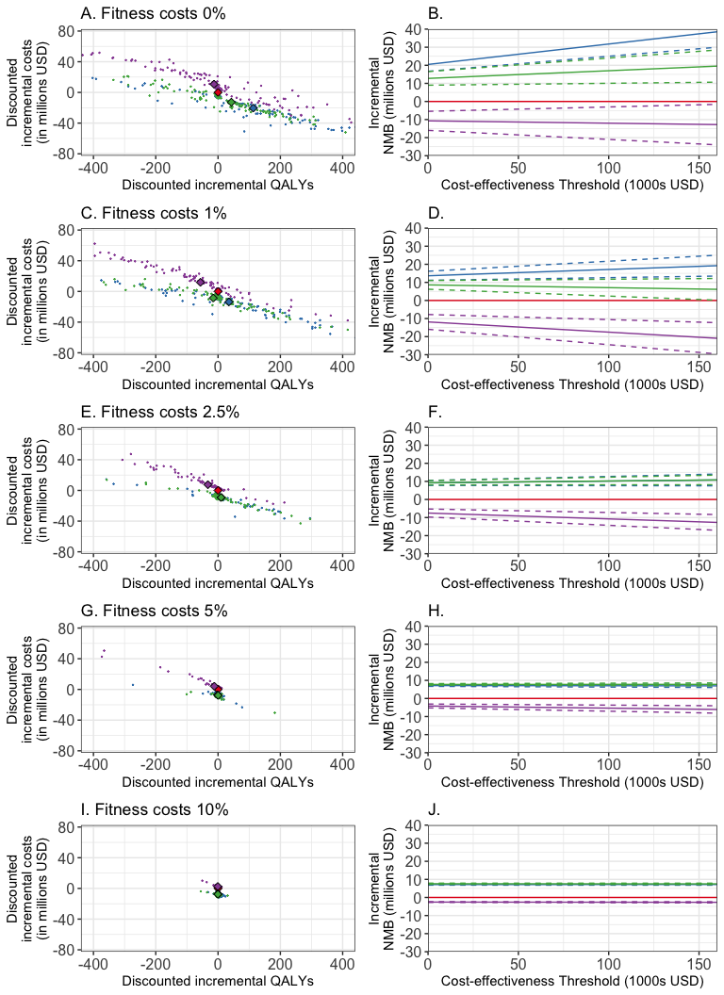
Figure. Cost-effectiveness analysis for different levels of fitness costs for resistant strains. A and B, 0% (same as main text results). C and D, 1%. E and F, 2.5%. G and H, 10%. As resistance becomes more costly for the bacteria, and therefore resistant strains are less prevalent, the counterfactuals converge in both costs and QALYs. GISP and randomized treatment are similar in terms of cost when there is little to no resistance in the population. Given that available evidence indicates that N gonorhoeae has very low fitness costs, and/or might quickly evolve compensatory mechanisms to overcome fitness costs, we maintain our conclusion that GISP is preferable over alternatives.

